**Types of company meetings**

Several types of meetings take place in the business organizations. Especially the company meetings can be shown by following diagram

1. Shareholders meeting: When the meeting is held with the shareholders of the company it is called shareholders meeting.

* (a) **Statutory meeting**: According to company laws, after getting the letter of commence, the company arranges a meeting after one month of six months. This is the first general meeting of the company and during the life of the company this type of meeting held once. The company gives the circular before 21 days of the meeting. The decisions of the meeting are called statutory decision.
* (b) **Annual general meeting**: After registration of the company, the company is bound to invites the first general meeting with in eighteen months. Then the general meeting will be held in every year. The differences of the two general meeting cannot be more than fifteen months. The decisions of the meeting are called general decision.
* (c)**Extra-ordinary general meeting**: If necessary of the company this type of meeting can be held on any time. The director or some shareholders can invite this meeting one tenth of the shareholders may give the requisition to the Board of directors to arrange this type of meeting. After getting the requisition of the board of Directors fail to arrange a meeting with in twenty one days, the shareholder can invite the meeting within three months. The decision taken by the meeting is called special decision.

[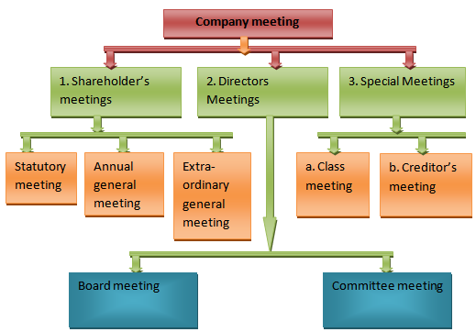](http://thebusinesscommunication.com/wp-content/uploads/2013/03/Types-of-company-meetings.png)

2. **Directors meeting**: When the meeting is held among the directors of the company it is called directors meeting. It is classified into two parts. They are:

* (a) **Board meeting**: According to article of association. The board of directors meeting is called Board Meeting. If nothing about this type of meeting in the article of association, then by Table- A rules of the company law this type of meeting can be held on. According to rules of company law the company is bound to arrange the meeting once in one month and at least four times within a year the Quorum: is filled up by 3/1 rd of the directors present or at least two directors present. Each director is preserved one vote and if any case the directors vote can be divided equally, then the president give the casting vote and take the decision.
* (b) **Committee meeting**: According to article of association the Board of Directors sometimes make special committee to complete in any special work among some directors of the company. This committee member sometimes meets together for coordinating the work properly. This type of seating is called committee meeting

3. **Special meeting**: For any special situation, when the meeting is arranged by the company, it is called special meeting. The types of the special meetings are as follows:

* (a)**Class-meeting**: The Company has different kinds of shares. When the meeting is arranged by any one kind of shareholders it is called class meeting.
* (b) **Creditors meeting**: The directors or their appointed lower can invite this type of meeting. Moreover this type of meeting may be arranged by the order of the court. If necessary to reconstruct or to dissolve or to any amalgamate the company to preserve the rights of the creditor this type of meeting is invited by their proper authoritative person. The creditors who will be present in the meeting or the presence of three-fourth credit holders of the total credit can take the decision and the court will give the instruction on the basis of this decision and the creditors are bounded to abide by the decision.